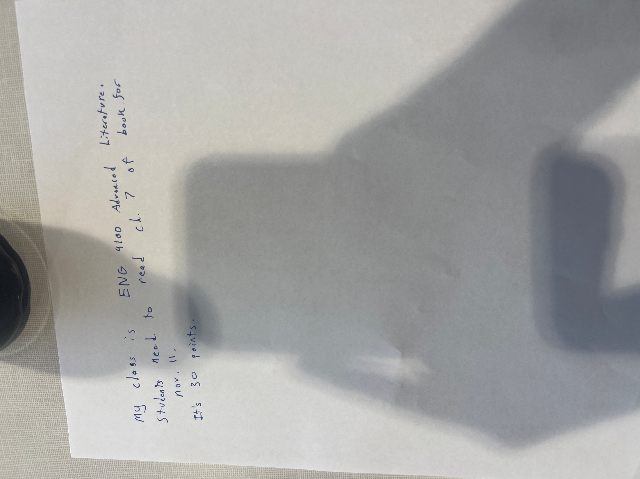

ENG 4100 Advanced Literature | Chapter 7 Reading | Reading | Students need to read chapter 7 of the book.|30||11/11

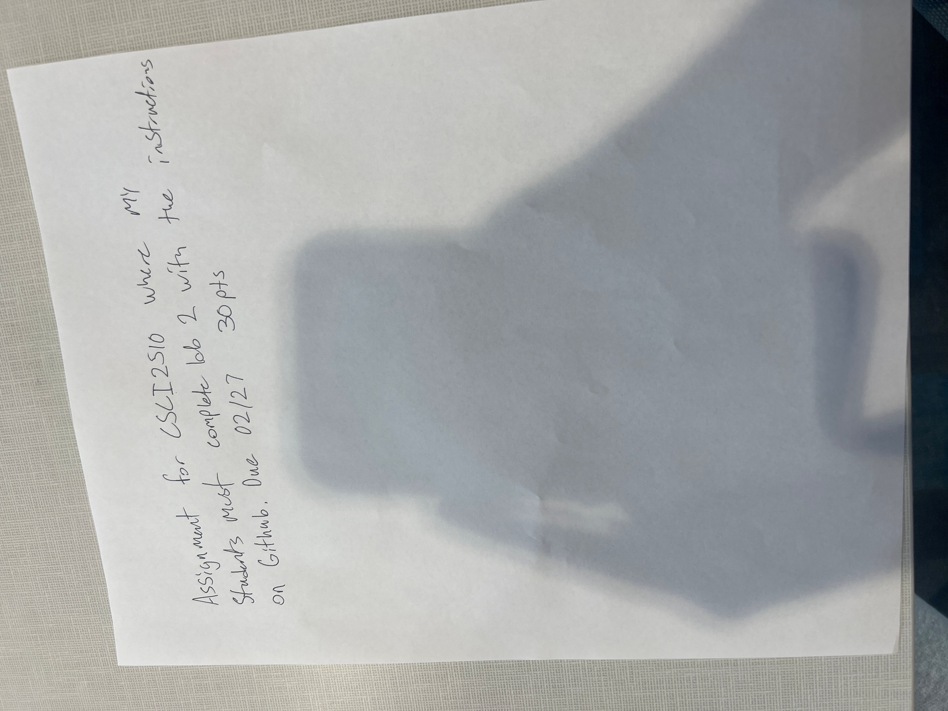

CSCI2510|Lab 2|Assignment|Complete Lab 2. Students must submit their lab work on Github.|30||02/27

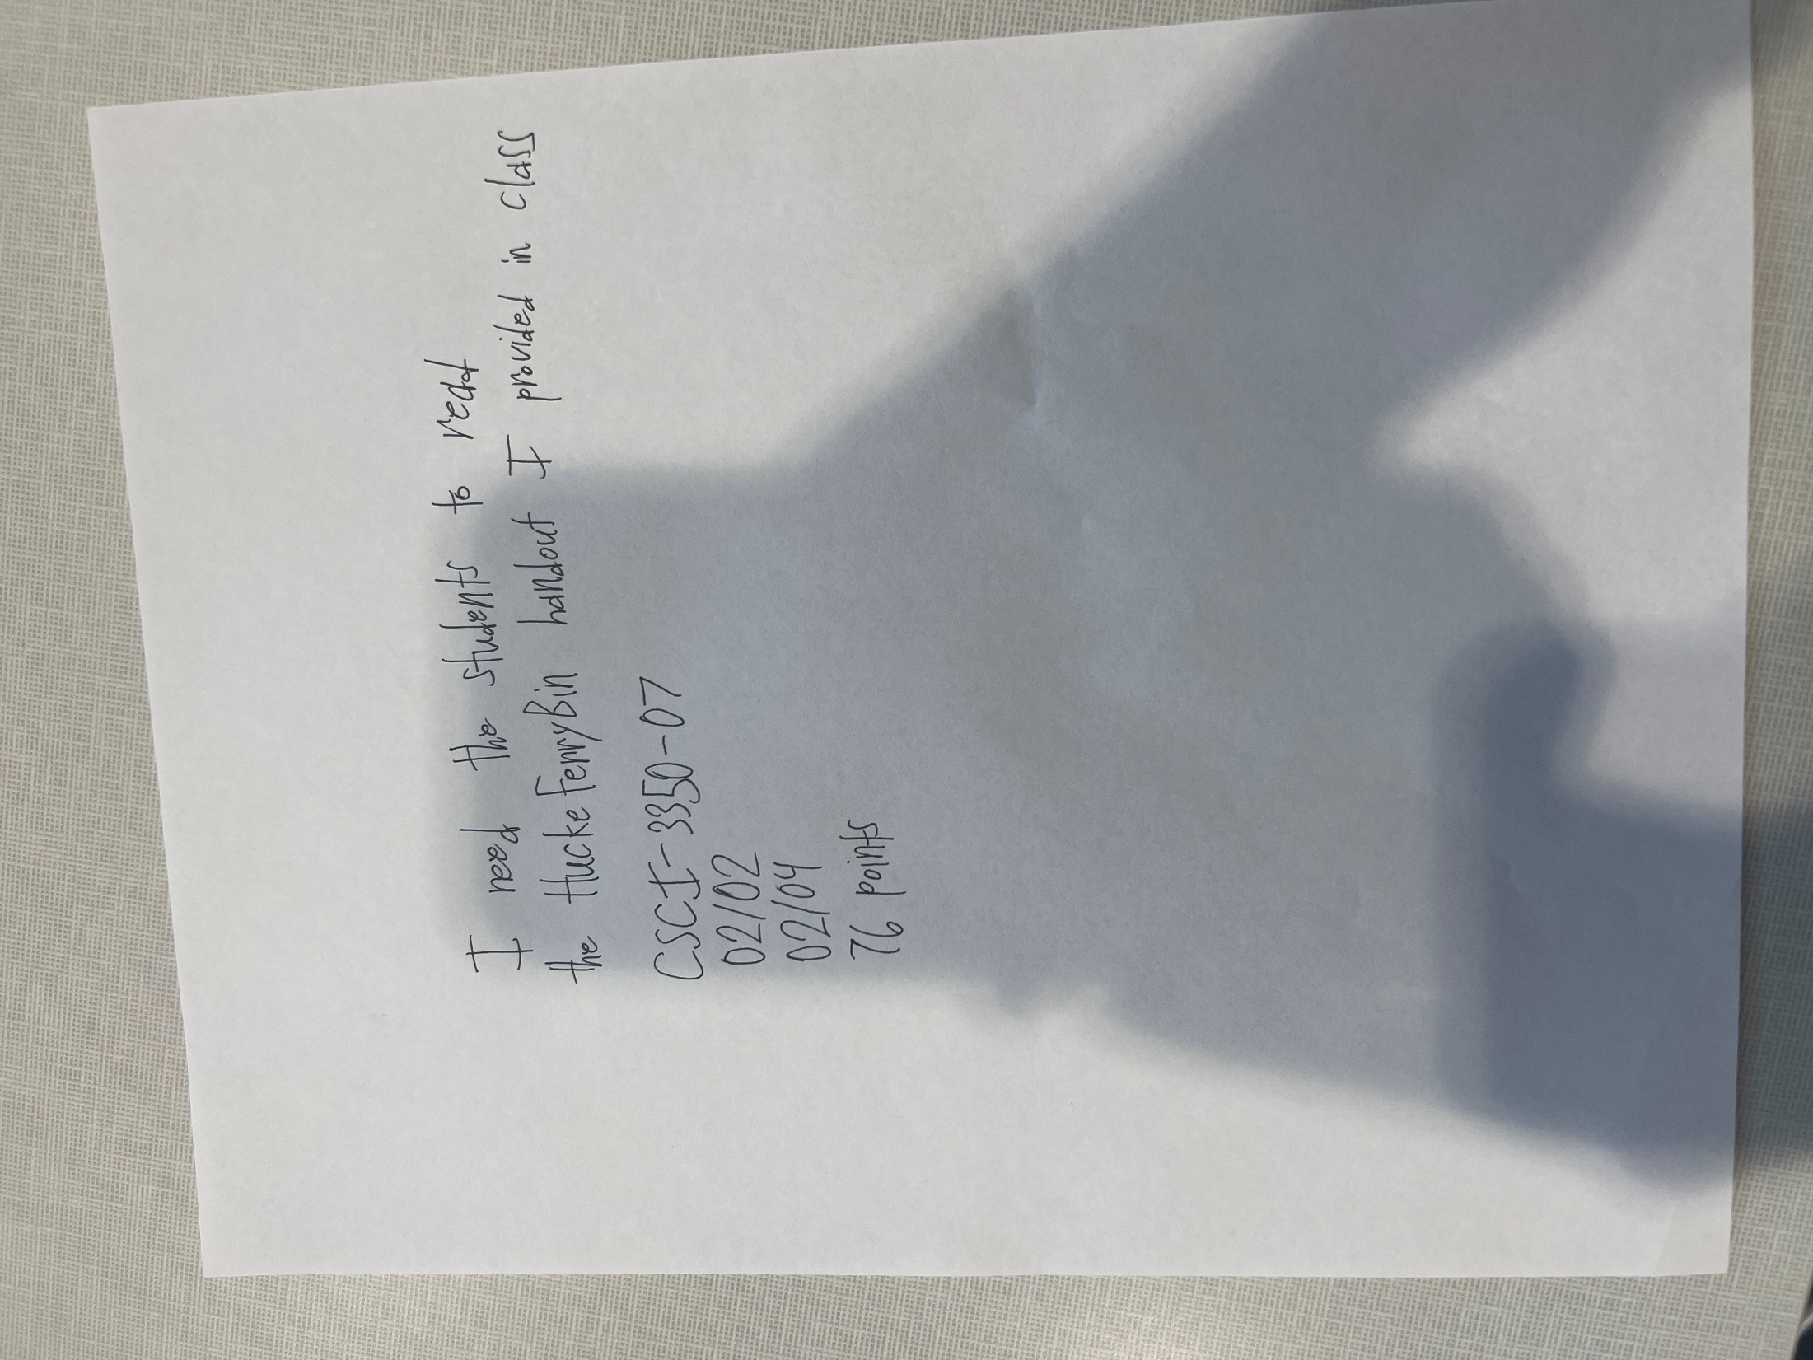

CSCI-3350-07|Hacke Ferry Bin Handout Reading|Reading|Please read the Hacke Ferry Bin handout provided in class.|76|02/20|02/04

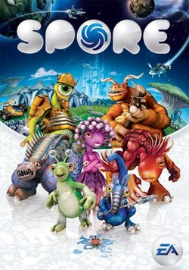

SPORE|SPORE EA Analysis|Assignment|Analyze the early access (EA) phase of the game SPORE.| | |

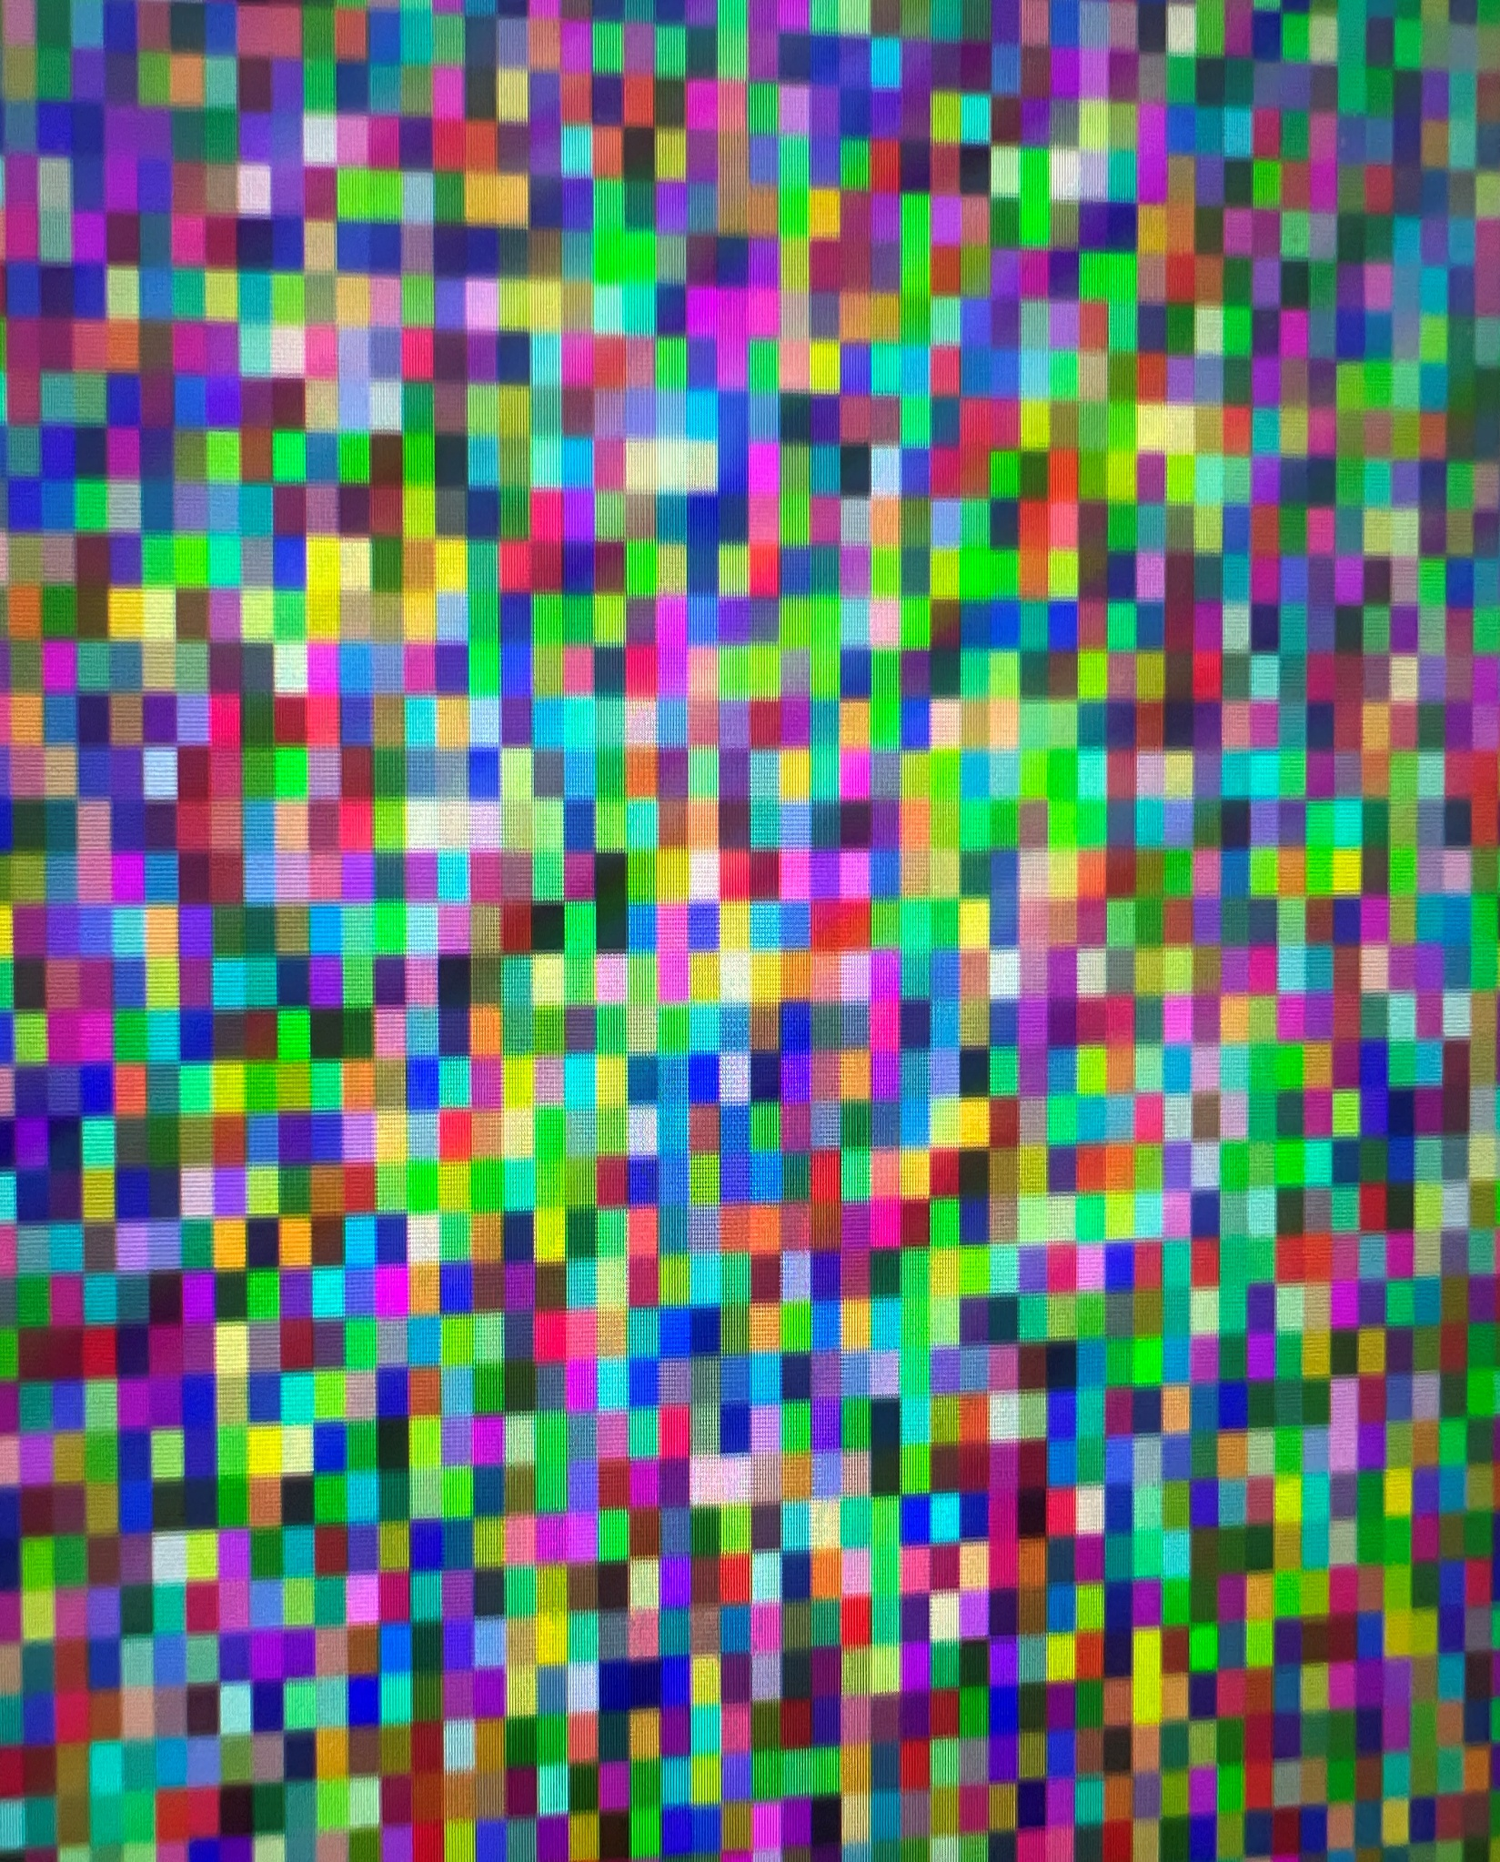

No text found in the image.

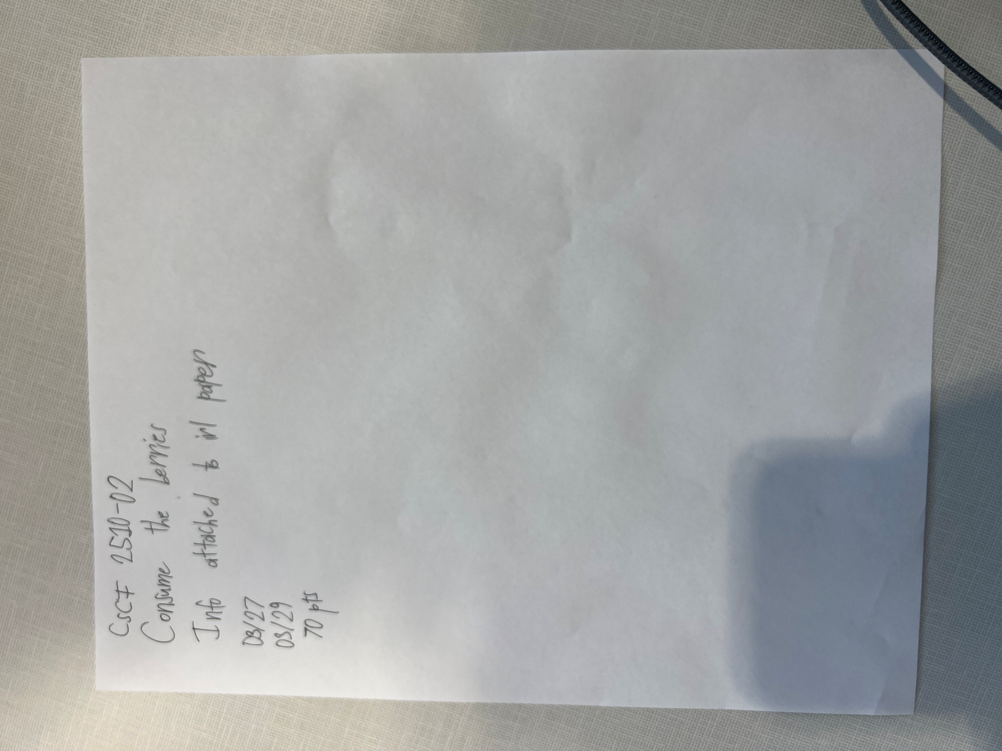

Csct 2510-02|Consume the berries|Assignment|Info attached to in paper|70|03/27|03/29

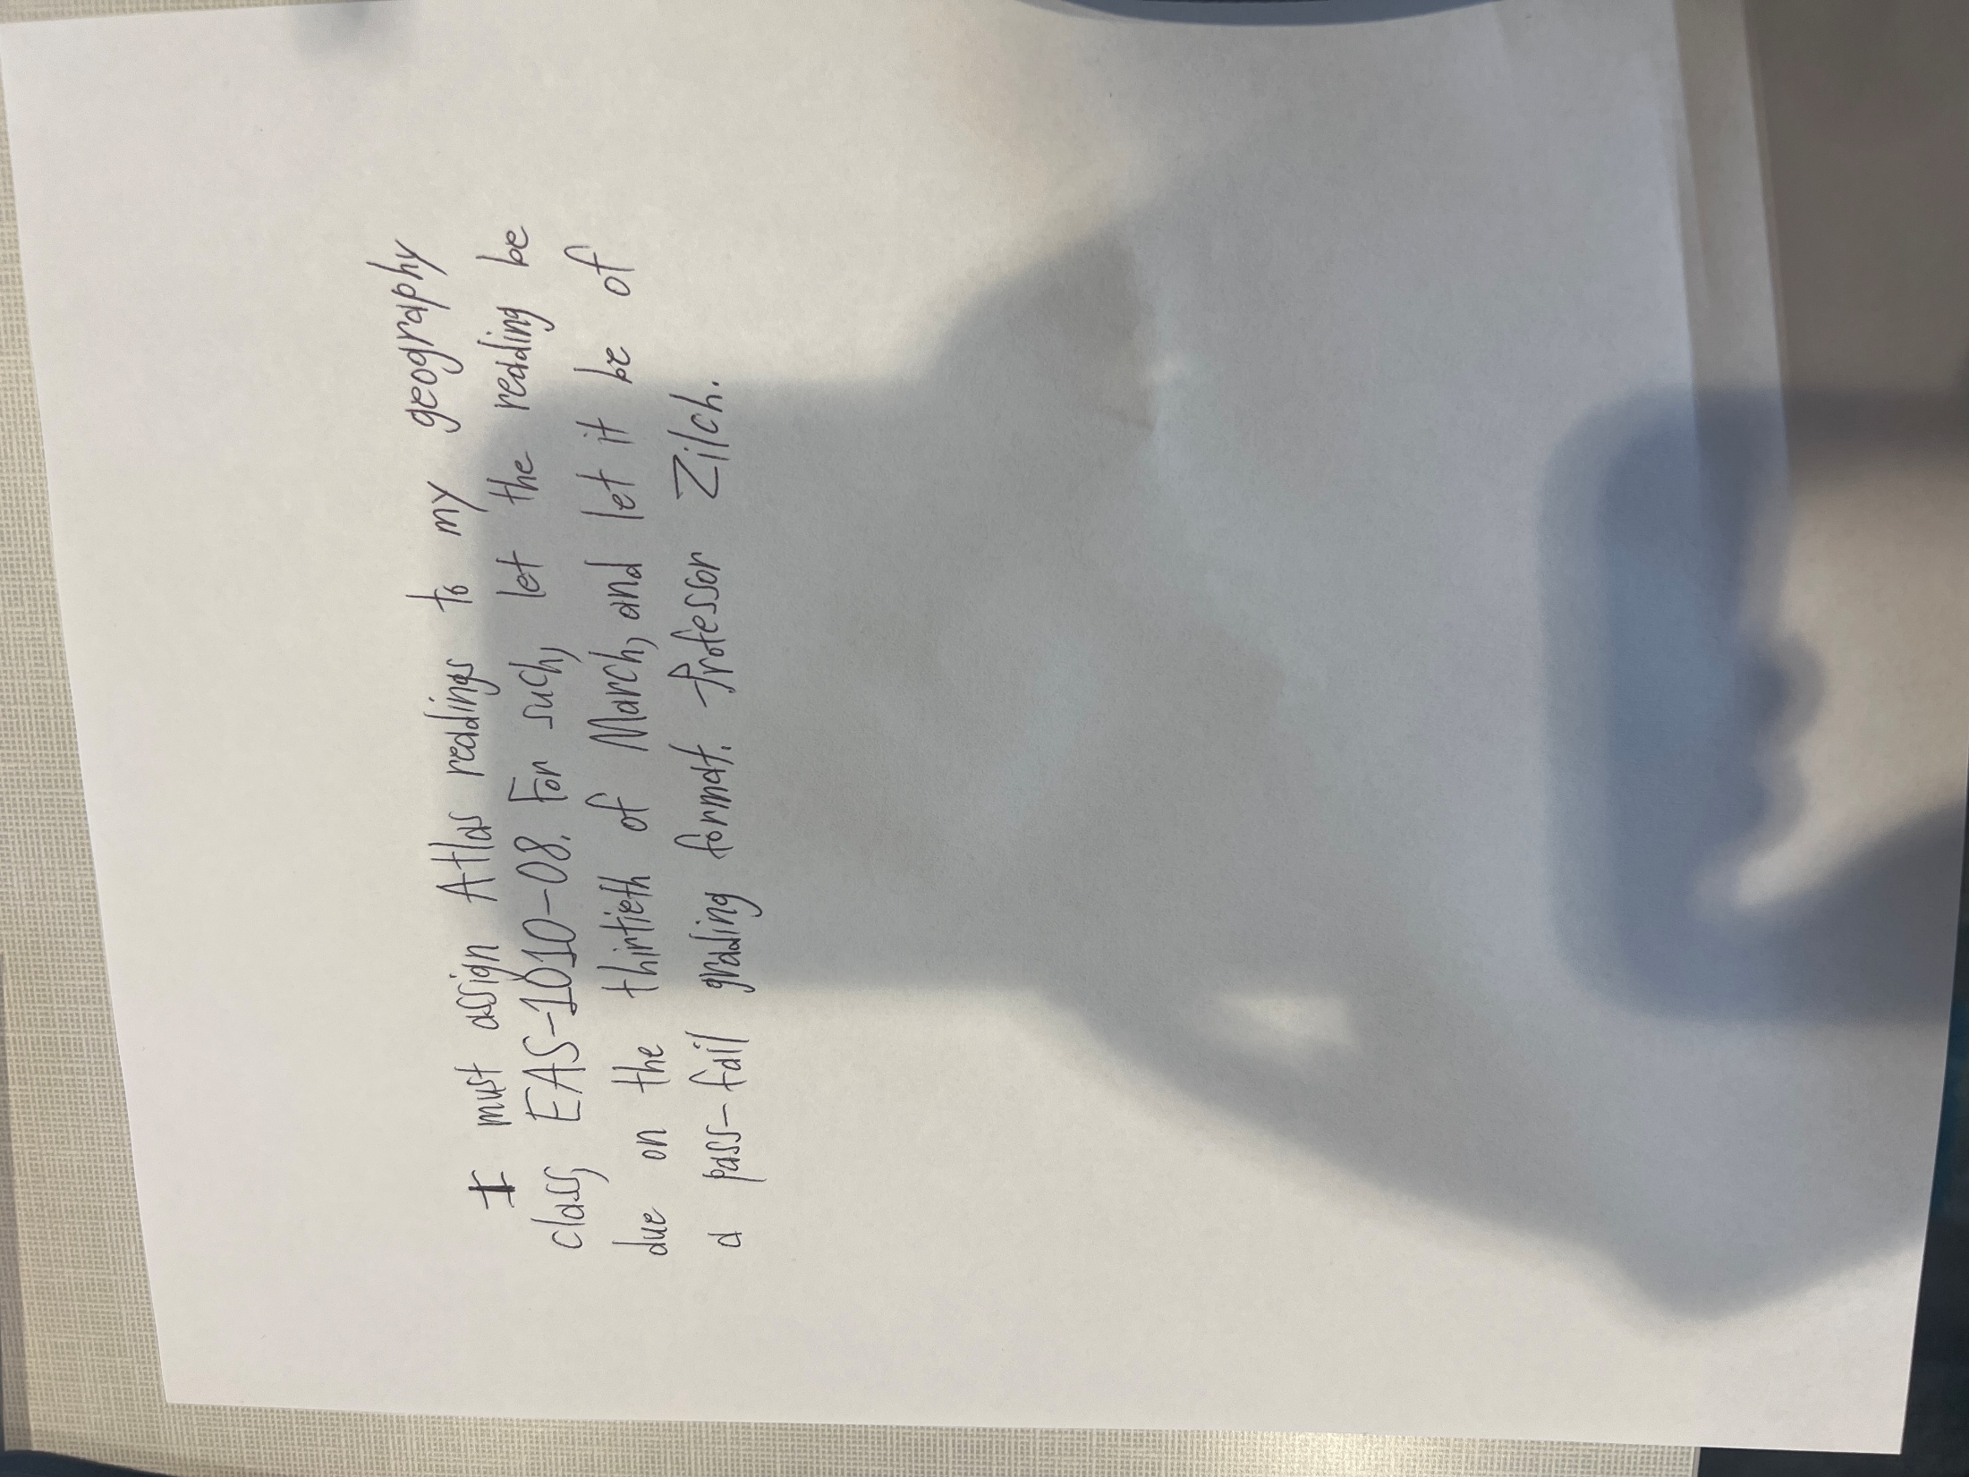

EAS-1010-08|Atlas Readings|Reading|Align Atlas readings to your geography class. This assignment is graded on a pass-fail format.| | |03/30

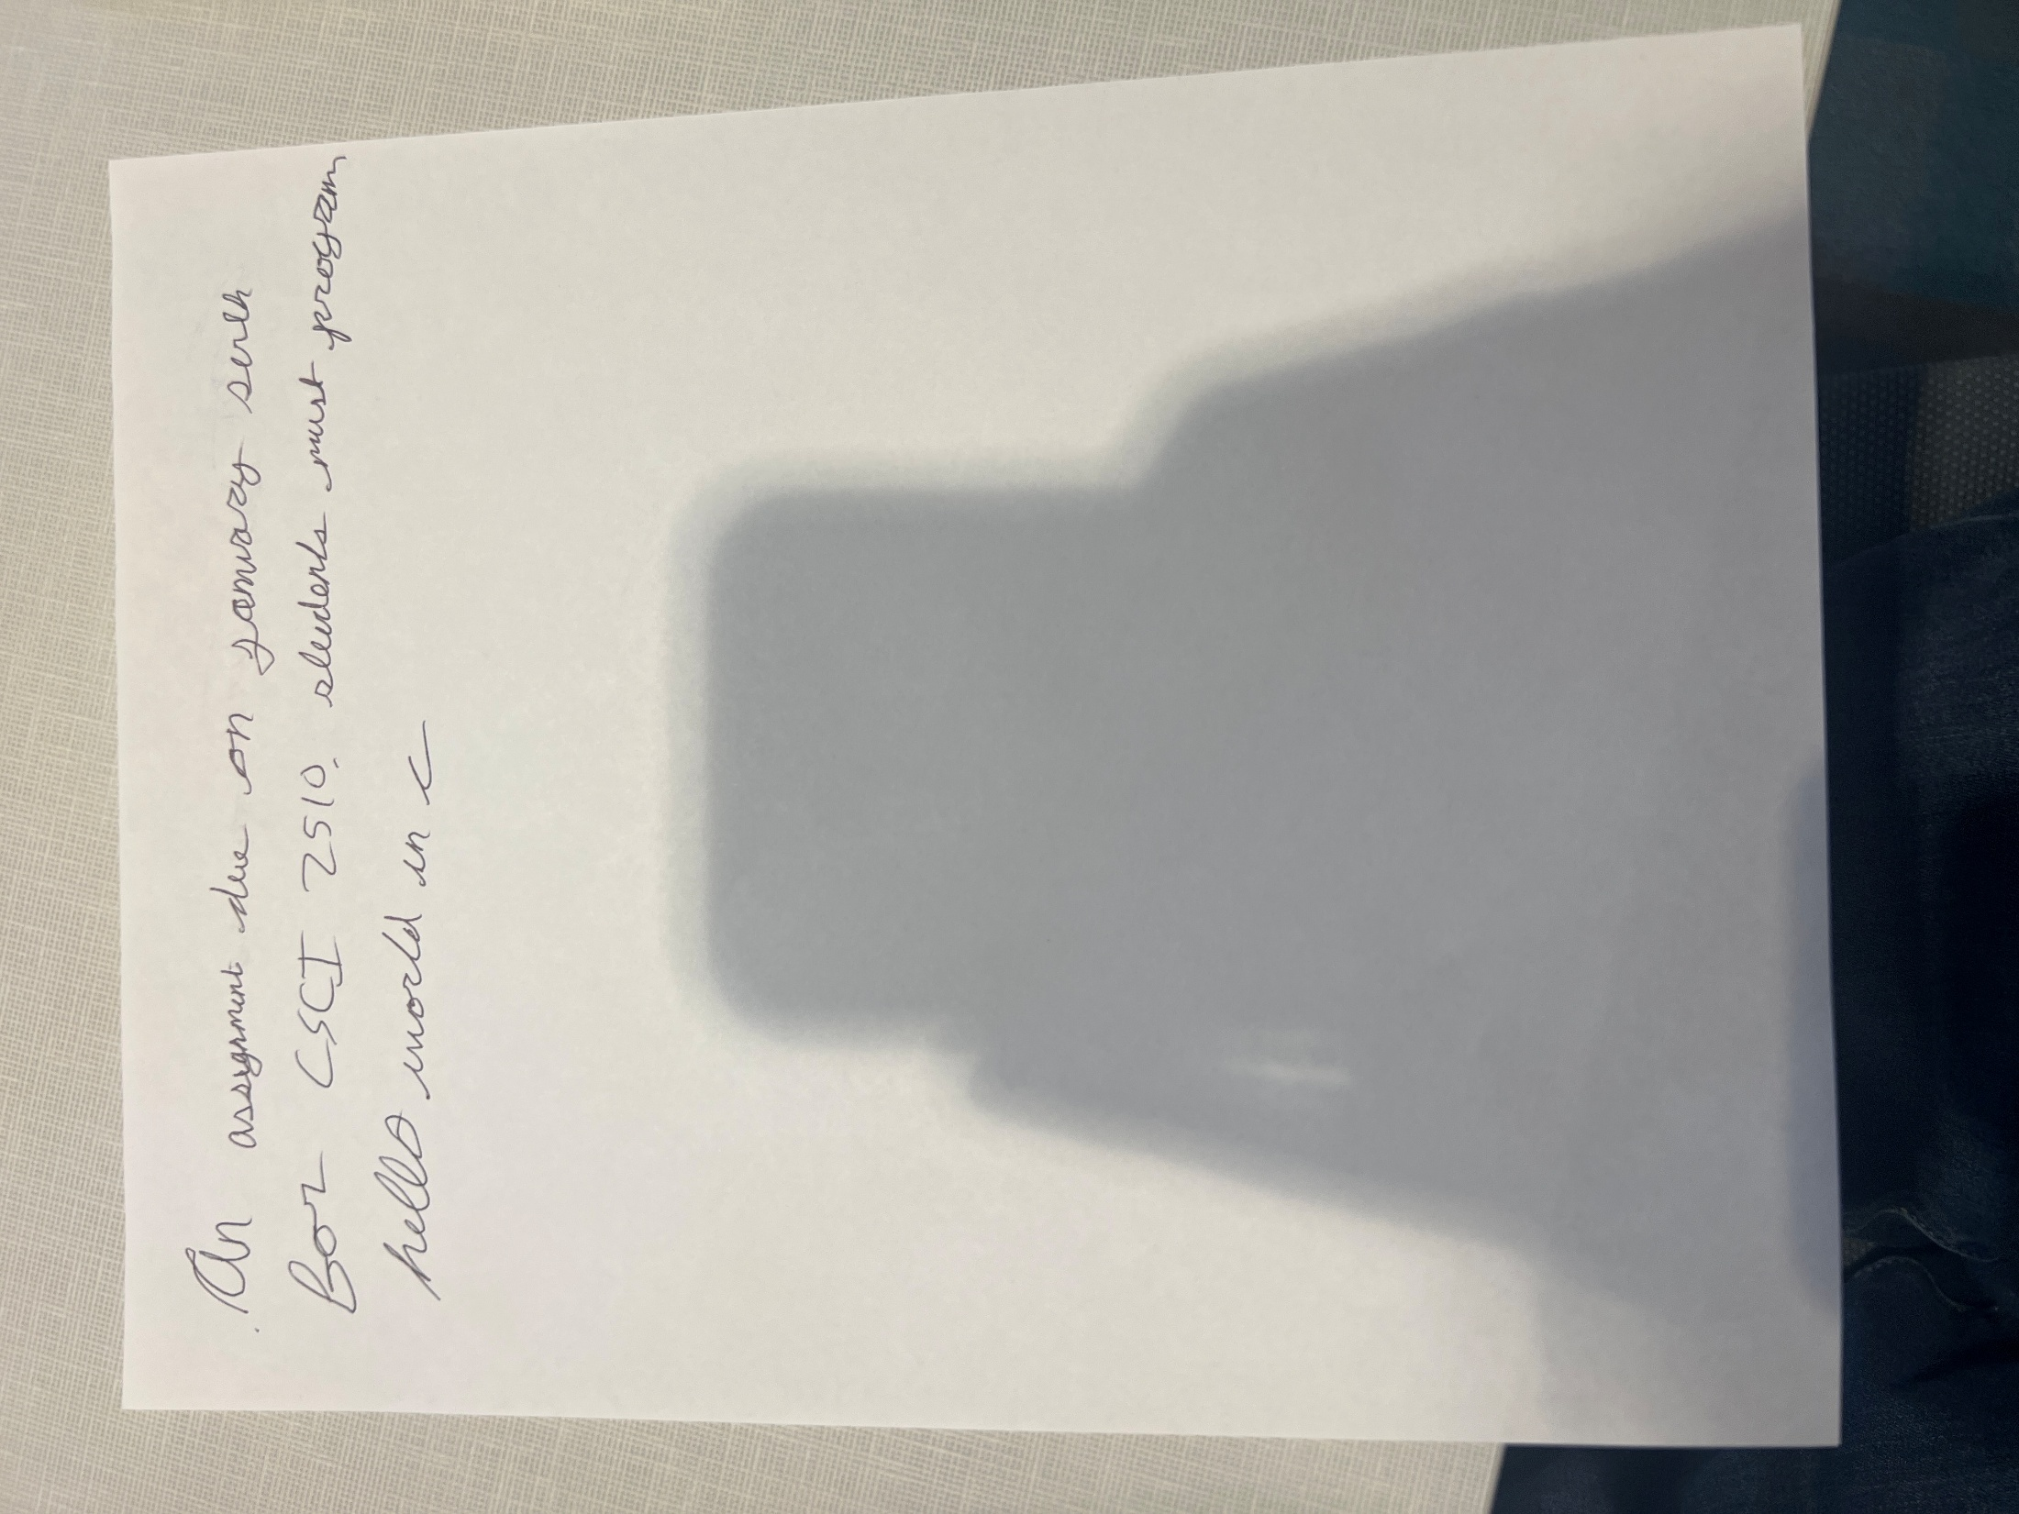

CSCI 2510|Hello World C Program|Assignment|For this assignment, students are required to write a ‘Hello World’ program in the C programming language.| | |01/07

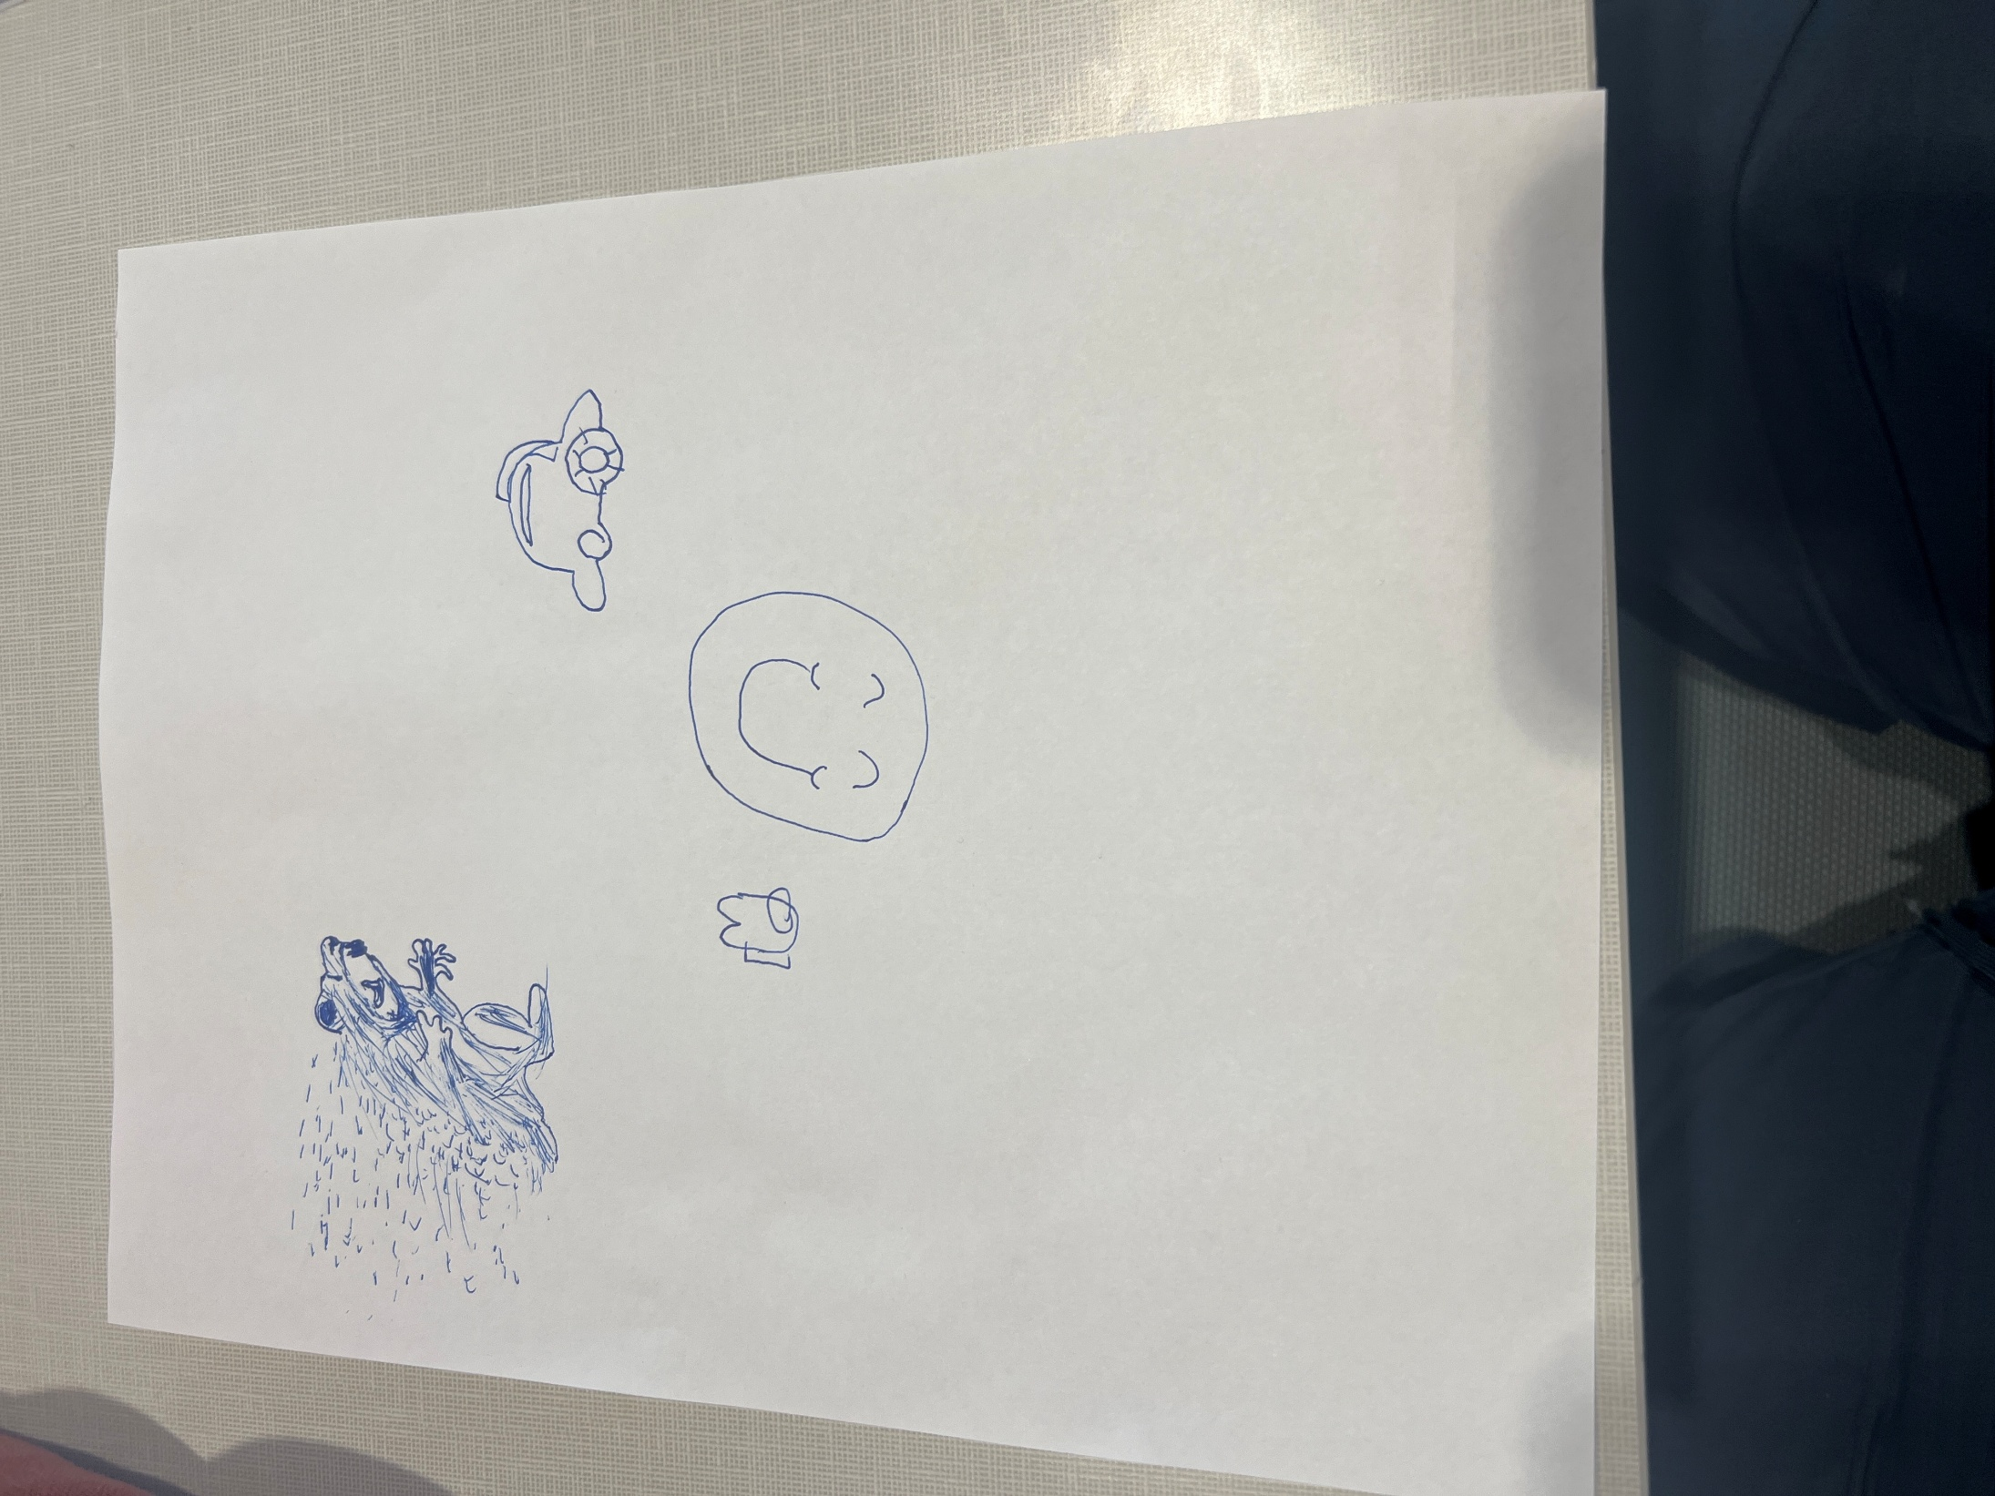

Please provide the text you are referring to! Once you give me the text, I will break it down into the requested segments for your Canvas API.